Name : Anupam Kunwar
Reg : 19BCE1369
Faculty : J.V Thomas Abraham

CSE1007 Lab Fat (L3-L4)

Q1.
Write a program to create two Name arrays in ArrayLists and uses an Iterator to count common elements in the first and second ArrayLists.

Solution :

import java.util.ArrayList;
import java.util.Iterator;
import java.util.Scanner;

public class Q1 {
public static void main(String[] args) {
Scanner in = new Scanner(System.in);
int counter = 0;
String s;
ArrayList<String> name1 = new ArrayList<String>();
System.out.println("Enter list 1 items : ");
for(int i = 0;i<4;i++){
s = in.next();
name1.add(s);
}

System.out.println("First Name Array : " + name1);
ArrayList<String> name2 = new ArrayList<String>();
System.out.println("Enter list 2 items : ");
for(int i = 0;i<4;i++){
s = in.next();
name2.add(s);
}
System.out.println("Second Name Array : " + name2);
name1.retainAll(name2); //Putting common elements in both array lists in name1
Iterator<String> itr = name1.iterator();
while(itr.hasNext()){
itr.next();
counter++;
}
System.out.println("The number of common elements in both array lists is "+counter);
}
}

Output :

1.
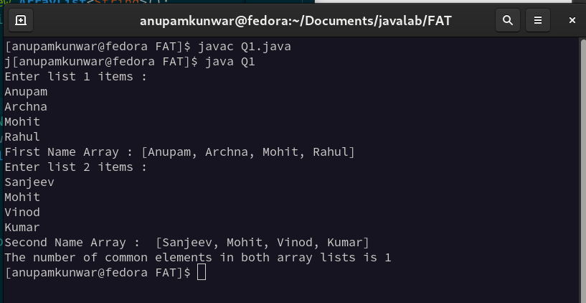

2.

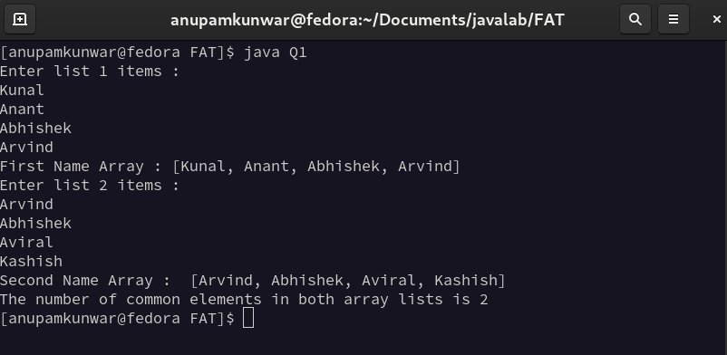

Q2.
Write a program to read in the child particulars like child name, date of birth (dd/mm/yyyy format) for a school admission. Your program should throw an exception if the age of the child is not more than 4 years.

Solution :

import java.util.Scanner;

class AgeException extends Exception{
AgeException(String s){
super(s);
}
}

public class Q2{

static void validate(int i) throws AgeException{
if(i<4){
throw new AgeException("Age not above 4 years!!");
}
else{
System.out.println("Age Valid");
}
}

public static void main(String[] args) {
Scanner in = new Scanner(System.in);
System.out.println("Enter Child's Name : ");
String name = in.next();
System.out.println("Enter Child's date-of-birth in DD/MM/YYYY : ");
String dob = in.next();
int y = Integer.parseInt(dob.substring(6));
int age = 2021 - y;
System.out.println("Age of "+name+" is "+age);
System.out.print("Result = ");
try{
validate(age);
}
catch(Exception e){
System.out.println("Exception occured : "+e);
}
}
}

Output :

1. Age below 4 years

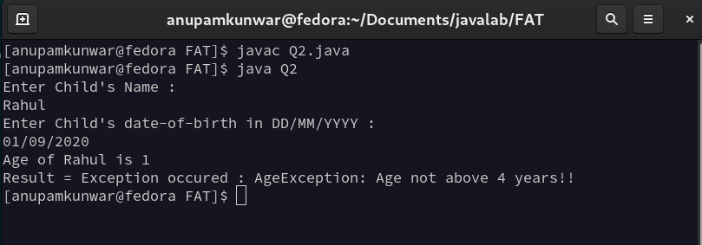
.

2. Age above 4 years

